**Healthy Meal Plan For Weight Loss**

THIS 5-DAY SAMPLE MEAL PLAN FOR WEIGHT LOSS IS ALL ABOUT EATING MORE, NOT LESS.

**You learn about lots of healthy, filling meals and snacks that can help you not only weigh less but also feel your very best.**

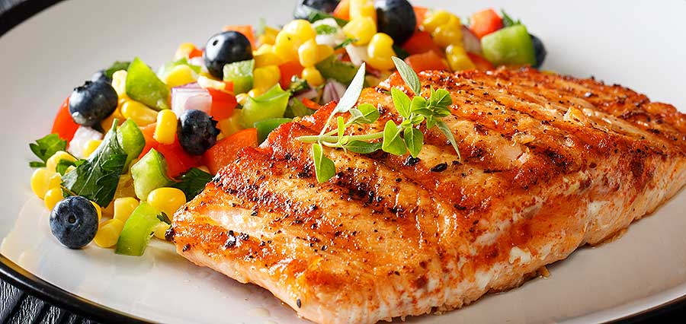

**DAY 1**

**Breakfast**

* Oatmeal with Fresh or Frozen (No Sugar Added) Fruit

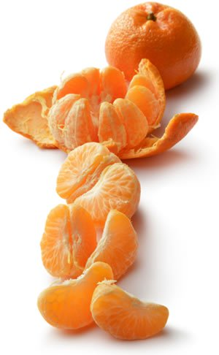

By switching from a bowl of cold, dried cereal to one of hot whole-grain cereal and fruit, you’d take in approximately 100 fewer calories each day. That one simple change to your daily diet could help you drop about 10 pounds in one year. Plus, hot cereal has more “staying power.” It tends to fill you up better – and longer – than dried cereal.

* Tea or Coffee

If desired, add a little nonfat milk or soymilk and a packet of sugar substitute (a good choice is Splenda).

**Mid-Morning Snack (enjoy *only* if hungry)**

* Veggie-Salsa Tortilla

1 steamed 6-inch corn tortilla with fresh or grilled vegetables (such as onions, green bell peppers, and tomatoes) and no-added-salt salsa.

Warm the tortilla between slightly moistened paper towels in the microwave for about 1 minute, then top with veggies and salsa; fold

* 1 Navel Orange or 2 Tangerines

**Lunch**

* 2 Cups Mixed Greens with 1 Cup of Other Veggies, Chopped, Dressed with Aged Balsamic Vinegar

For your salads, break out of the lettuce-and-tomato box. All kinds of veggies – and fruit – can go into your salad. Try diced sweet potatoes, yellow squash, red bell peppers, cucumbers, red cabbage, red onions, and more.

And always keep in mind that no oil, even so-called “good” ones, should be considered a weight-loss food. Coating your salad with oil can tally up as many calories as a scoop of premium ice cream.

* Hearty Italian-Style White Bean Soup

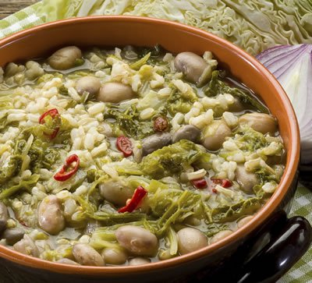

Make your own. It’s easy! From one 14-ounce can of no-salt-added cannelini beans, spoon out 2 tablespoons of beans. Puree the rest. In a medium nonstick pot, sauté 5 cloves of chopped garlic until translucent. Add 2 cups low-sodium chicken broth and 1 head of escarole, chopped, or a package of frozen chopped spinach. Simmer for about 15 minutes. Add pureed beans, red pepper flakes and black pepper, to taste, and cook 1 minute longer. Garnish with the beans you spooned out plus, if you desire, a little chopped red bell pepper. Refrigerate or freeze what you don’t eat for easy soup prep for a future lunch or dinner.

**Mid-Afternoon Snack (enjoy *only* if hungry)**

* 6 Ounces of Nonfat Plain or No-Sugar-Added Yogurt with Your Choice of Berries Swirled Throughout

Especially popular among our guests at the Pritikin Longevity Center are Greek-style yogurts such as Oikos and Fage. So rich and creamy tasting! If you need a little sweetness to cut the tart flavor, simply add diced banana, or stir in 1 packet of Splenda

* 1 Apple

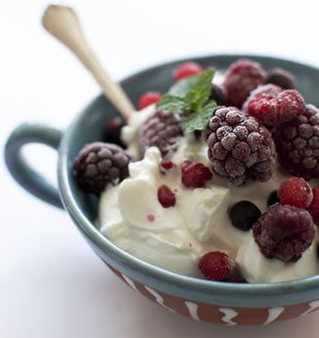

**Dinner**

* Salad

A gigantic Farmer’s Market-style salad with a variety of fresh seasonal produce and fresh herbs, such as fresh baby arugula and radicchio, and red wine vinegar sassed up with a little horseradish. Enjoy visiting your local Farmer’s Market every week and asking the vendors, “What’s new and tasty this week? What would make great ingredients for my salad?”

* Salmon with Sweet Chili Sauce (3½ to 4 ounces)

[Get the Recipe »](https://www.pritikin.com/recipe/salmon-sweet-chili-sauce)

When dining out and ordering fish, request that your fish not be salted or basted in calorie-dense ingredients like olive oil and butter. Healthier cooking options include steaming, broiling, or grilling.

* Baked Potato with 2 Tablespoons Fat-Free Sour Cream and a Sprinkling of Chives or Scallions

Contrary to popular belief, potatoes are a great food for helping you lose weight. It’s what we put *on top of* our potatoes – butter, cheese, and bacon bits – that turn them into waistline-busting foods.

**Dessert (*only* if hungry)**

* Mixed Berries

**DAY 2**

**Breakfast**

* Egg White Omelet

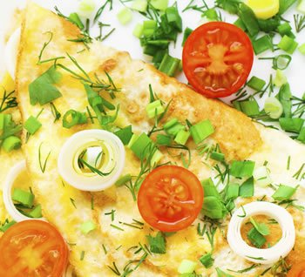

Egg white omelet stuffed with 1 cup of assorted grilled vegetables, such as onions, bell peppers, mushrooms, and broccoli, and a dollop of nonfat ricotta cheese.

* Hash Browns

In a nonstick skillet misted with a little cooking oil spray, stir fry until brown diced baked potatoes with sliced onions, sliced green bell pepper, freshly ground black pepper, and paprika.

* Bowl of Blueberries, Fresh or Frozen (No Sugar Added)
* Tea or Hot Cocoa, if desired

Yes! Cocoa can be part of a healthy meal plan for weight loss! For cocoa: Mix nonfat milk or soymilk, 1 tablespoon cocoa powder, and 1 packet of sugar substitute, such as Splenda (if desired).

**Mid-Morning Snack (enjoy *only* if hungry)**

* Big Handful of Grapes

Like vegetables, fruits are fabulous weight-loss foods because they’re “big” foods, that is, foods that are bulked up by lots of fiber and water. With “big” foods, you’ll be eating a lot of food (which will satisfy your hunger) but not a lot of calories.

Here’s a great example: For the same number of calories that are in a handful of peanuts (about two ounces), you can eat 2½ *pounds* of strawberries (about five of those green boxes that strawberries come in.) Eating “big” foods like strawberries, salads, and other fruits and vegetables can prevent hunger from taking over and taking you places you don’t want to go

**Lunch**

* Salad

Big salad of baby greens with Pritikin-Style Thousand Island Dressing, which has less than one-quarter the calories and sodium of regular Thousand Island Dressing. What a gift for your heart *and* waistline! To make dressing, combine thoroughly the following: ¾ cup plain fat-free Greek yogurt, ½ cup fat-free sour cream, ¾ cup unsweetened, low-sodium ketchup (good brand is Westbrae), ½ teaspoon oregano, and ½ teaspoon granulated garlic.

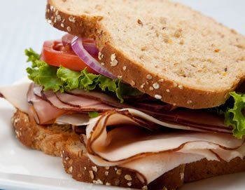

* Turkey Sandwich

Sandwich of fresh roasted turkey breast (3½ to 4 ounces) with 2 slices of low-sodium, whole-grain bread with assorted veggies, like baby greens and sliced tomatoes. Smear the bread with 1 tablespoon of low-sodium stone-ground mustard.

Did you know that bread and rolls are the No. 1 source of salt in the American diet, accounting for more than twice as much sodium as salty junk food like potato chips? That’s why it’s so important to look for low-sodium varieties of bread (a good brand is Food for Life).

**Mid-Afternoon Snack (enjoy *only* if hungry)**

* Pear
* Popcorn – air-popped or fat-free microwave

Did you know that it takes 2 *quarts*of air-popped popcorn to equal the calories in just 20 potato chips? Be sure to eat a piece of fruit with the popcorn to help improve its satiety value!

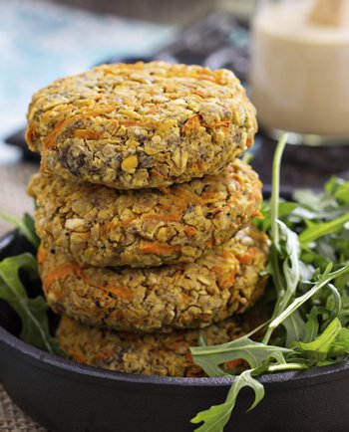

**Dinner**

* Veggie Burger on a Whole-Wheat Bun with Roasted Red Bell Peppers

Keep stocked in your refrigerator or freezer a box of veggie burgers (look for low-sodium varieties). Veggie burgers are a much better choice for your waistline and heart than ground meat. Veggie patties have only about half the calories of regular red meat patties, and zero heart-hurting saturated fat. Plus, they’re so easy to cook – just one or two minutes in the microwave. While toasting your whole-wheat bun, take from your pantry a jar of roasted red bell peppers and top your veggie patty with a couple of luscious slices. Smear your bun with a little low-sodium Dijon mustard.

* Steamed Fresh Vegetables

1 or more cups (it’s hard to go overboard on fresh veggies!) of steamed fresh vegetables, such as asparagus, broccoli, and/or cauliflower, with lemon juice and sautéed garlic.

**Dessert (*only* if hungry)**

* Fresh Berries

1 cup fresh strawberries, plain or drizzled with 1 tablespoon balsamic vinegar or Marsala wine

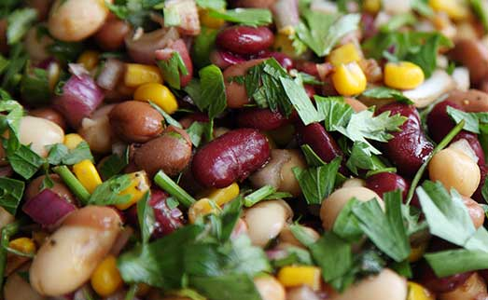

**DAY 3**

**Breakfast**

* Hot Whole-Grain Cereal with Blueberries

Hot whole-grain cereal, such as oatmeal, cracked wheat, barley or polenta, made with 1 cup nonfat milk or soymilk and 1 cup fresh or frozen blueberries.

There are many great choices of whole-grain hot cereals; just make sure you buy one with no added sugar or salt.

* Tea or Coffee

If desired, add a little nonfat milk or soymilk and 1 packet of sugar substitute (a good choice is Splenda).

**Midmorning Snack (enjoy *only* if hungry)**

* 1 Cup Diced Watermelon or Other Seasonal Fresh Fruit
* 1 Snack Bag of Baby Carrots

**Lunch**

* Vegetarian Chili

Look for fat-free low-sodium varieties, or make your own.

[Get the Recipe »](https://www.pritikin.com/your-health/healthy-living/eating-right/pritikin-recipes/vegetarian-chili.html)

* 1 Ear of Corn

Did you know that *four* ears of corn has the same number of calories as one medium serving of French fries? (The corn tastes better, too.)

**Mid-Afternoon Snack (enjoy *only* if hungry)**

* Cottage Cheese and Fruit

½ cup 1% no-salt-added cottage cheese with ½ cup to 1 cup fresh diced fruit, or use pop-top canned fruits packed in juice or water, no sugar added.

**Dinner**

* Spinach Salad

A big salad of baby spinach and other fresh veggies, such as sliced carrots and tomatoes, topped with your favorite canned no-salt-added beans. Toss salad with about ½ teaspoon of wasabi (to taste) and 3 to 4 tablespoons of rice vinegar.

Look for no-salt-added varieties of canned beans since rinsing the beans through a colander removes only 30% of the added sodium.

* Chicken with Cherry Tomatoes

[Get the Recipe »](https://www.pritikin.com/your-health/healthy-living/eating-right/pritikin-recipes/chicken-breasts-with-cherry-tomatoes.html)

* Brown Rice

Give your brown rice a nice savory spin by adding freshly minced garlic. At the last minute, add in fresh herbs like thyme and Italian parsley and just about any vegetable you have on hand, like chopped cucumbers, celery, onions, and tomatoes.

**Dessert (*only* if hungry)**

* Frozen Yogurt

¾ cup frozen strawberry nonfat sugar-free yogurt topped with sliced fresh or frozen unsweetened strawberries

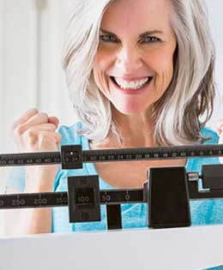

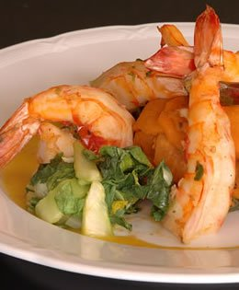

**DAY 4**

**Breakfast**

* 1 Cup Fresh Fruit
* 1 Cup Nonfat Plain or Nonfat, No-Sugar-Added Yogurt
* ½ Whole-Grain Bagel, Toasted. Top with Fat-Free Cream Cheese or Nonfat Ricotta Cheese and Fresh Sliced Strawberries
* Tea or Coffee

If desired, add a little nonfat milk or soymilk and 1 packet of sugar substitute (a good choice is Splenda).

**Mid-Morning Snack (*only* if hungry)**

* 1 to 2 Cups of Veggie-Rich, Bean-Rich Low-Sodium Soup, such as…

Red Bean and Leftover Veggie Soup

While there are probably plenty of pre-made bean and veggie soup options that just need a few minutes to heat through on the stovetop, making your own soup is really easy—and a great idea for your health. Homemade soups are much lower in sodium – about 100 milligrams or less per 2-cup serving. By contrast, 2 cups of many canned soups contain a blood-pressure-busting 1,200 milligrams or more, a worrisome amount considering that health experts recommend consuming no more than 1,500 milligrams of sodium *for the entire day*. This is also a great way to use up all those leftover vegetables in your crisper—pretty much anything works in this soup.

Directions:  
Put into a soup pot 1 can of no-salt-added red beans (drained), 4 cups low-sodium vegetable juice like Knudsen’s Very Veggie Low-Sodium Juice, 2 to 3 teaspoons oregano or Italian-style seasoning, and 2 cups of any veggies you already have sitting in the refrigerator bin, such as carrots, celery, and onions. Rough-chop the vegetables into bite-size pieces and bring to a boil, simmering until vegetables are crisp-tender, about 10 to 15 minutes. If desired, top with a tablespoon of fat-free sour cream.

**Lunch**

* Tuna Sandwich

Put together a sandwich of tuna (canned – preferably low-sodium, light, and packed in water) with 1 tablespoon nonfat mayo or nonfat plain yogurt, chopped celery, and onions, topped with baby spinach or peppery arugula, on 100% whole-wheat bread (low-sodium)

* Carrot and Pineapple Salad

[Get the Recipe »](https://www.pritikin.com/your-health/healthy-living/eating-right/pritikin-recipes/carrot-and-pineapple-salad.html)

**Mid-Afternoon Snack (*only* if hungry)**

* Sweet Potato

Enjoy the rich flavor of sweet potatoes? While home on Sundays, cook up a batch. Wrap each one in foil and bake for about an hour at 425 degrees F, or until their luscious, sweet juices start to ooze out into the foil. At work the following week, just pop one in the microwave for a quick warm-up. They’re loaded with taste, so they don’t need any extra toppings. If you want a little zest, swirl in a teaspoon or two of no-salt-added Dijon mustard or a quarter cup of plain nonfat Greek yogurt.

**Dinner**

* Salad with Honey Mustard Dressing

A big salad with a variety of lettuces, plus tomatoes, cucumber, and any other veggies you have in the fridge, including varieties you’ve never thought of adding to salads but actually taste delicious, like sliced fennel.

Honey Mustard Salad Dressing

[Get the Recipe »](https://www.pritikin.com/your-health/healthy-living/eating-right/pritikin-recipes/honey-mustard-dressing.html)

* Curried Quinoa and Tofu

Ah, quinoa. This healthy, rich-tasting whole grain/seed has so many nutritional riches that it puts refined grains like white rice to shame. Tofu is the perfect sidekick because it’s both waistline-friendly (per bite, tofu tends to have about one-third the calories of meat and poultry) and heart-friendly (tofu has no artery-damaging saturated fat or cholesterol).

Directions: Rinse 1 cup of quinoa in cold water. In a medium saucepan, combine quinoa with 1 tablespoon curry powder and 1 teaspoon turmeric. Add 2 cups low-sodium chicken broth and bring to a boil. Cover and simmer until the water is absorbed—about 15 minutes. Stir in 1 cup shredded carrots and 1 cup cubed firm tofu. Makes about 4 one-cup servings. Refrigerate remaining servings for an easy, healthy snack or meal later in the week.

**Dessert (*only* if hungry)**

* Berry Mousse

Blend together until smooth and creamy your favorite fresh berries, silken tofu, Splenda (if needed), and a little vanilla extract.

**DAY 5**

**Breakfast**

* Orange-Vanilla Oatmeal

Think oatmeal is boring? You haven’t tried Chef Anthony’s Orange-Vanilla Oatmeal, always a favorite among guests at Pritikin. It’s a great meal for losing weight, and starting your day.

[Get the Recipe »](https://www.pritikin.com/recipe/orange-vanilla-oatmeal)

* Tea or Coffee

If desired, add a little nonfat milk or soymilk and 1 packet of sugar substitute (a good choice is Splenda).

**Mid-Morning Snack (*only* if hungry)**

* Carrots and Hummus

Open up a big bag of baby carrots and dip them into your freshly made no-oil-added, no-salt-added hummus. Simply whip up in your food processor a can of no-salt-added chickpeas/garbanzo beans, fresh tomatoes, lemon juice, garlic, a jalapeno pepper (if you like your hummus hot and spicy), and fresh herbs like cilantro and dill. Add a little water, if necessary, until the desired consistency is achieved.

**Lunch**

* Tomato Cream Soup

[Get the Recipe »](https://www.pritikin.com/your-health/healthy-living/eating-right/pritikin-recipes/tomato-cream-soup.html)

* Butter Beans With Lemon and Scallions

Butter beans are as delicious as they sound: big, meaty and filling, with a mild flavor that works well with bright, assertive flavors like lemon and scallions.

1 can no-salt-added butter beans  
½ cup chopped scallions (also known as green onions)  
Juice from half a lemon  
Red chili pepper flakes, to taste  
2 to 3 cups chopped fresh Romaine lettuce and/or baby arugula

In a medium mixing bowl, combine butter beans, scallions, lemon juice, and pepper flakes. Spoon over lettuce greens.

**Mid-Afternoon Snack (enjoy *only* if hungry)**

* 1 to 2 Cups of Fresh Fruit

Take advantage of grocery store salad bars and pick up containers of pre-cut fresh fruit like melon.

**Dinner**

* Easy Tangy Salmon

Sear, skin side up, a 4-ounce cut of salmon in a hot nonstick skillet and cook until well browned on the bottom, 3 to 5 minutes. Turn and cook till slightly translucent in center, 1 to 3 minutes. Transfer salmon to serving dish. To skillet add ¼ teaspoon grated orange peel, 3 ounces orange juice, and ½ cup white wine. Boil until reduced by half, about 3 minutes. Stir in 1 teaspoon fresh thyme leaves. Spoon sauce over salmon.

* Soba Noodles With Spicy Cucumbers

Cooking up soba (the Japanese word for buckwheat) noodles instead of white-flour noodles is a great way to cut calories. A cup of soba has just 113 calories; a cup of white pasta, about 200. Plus, soba noodles are full of fiber, protein, and B vitamins.

Combine in large bowl:  
2 large cucumbers, peeled, seeds removed, and sliced  
½ tablespoon paprika  
Pinch cayenne pepper  
Pinch black peppercorns, freshly ground  
½ cup fresh lemon juice  
Let cucumber mixture sit for a few minutes while you cook 8 ounces of soba noodles according to package directions. After cooking and draining sobas, toss in bowl with cucumber mixture and gently blend.

* 1 to 2 Cups Sautéed Spinach

Pour a 6-ounce bag of pre-washed baby spinach in a hot wok sizzling with a small amount of water or white wine, 1 tablespoon of lemon juice, and minced garlic. Stir spinach till wilted.

**Dessert (*only* if hungry)**

* Fruit Smoothie

Smoothie made in blender with 1 cup nonfat plain yogurt, ¾ cup crushed ice, ½ banana, and fresh or frozen berries